AI-Persona Debates in Monetary Economics: A History-of-Thought Activity
Dr Camilo Calderon · Monetary Economics
Submitted to the Economics Network Ideas Bank
AI disclosure: This case study was drafted with AI writing assistance (Claude, Anthropic). All scholarly claims, evidence, and interpretations have been reviewed and approved by the named author.

Background
Monetary economics has inherent challenges for teaching well at the undergraduate level. The core of the Classical–Keynesian controversy is a debate – philosophical in essence, not a matter of competing calculations but of competing assumptions: whether Say's Law survives in a monetary economy, whether liquidity preference collapses the interest-rate channel at the zero lower bound, or whether the Pigou effect provides a self-correcting escape from a liquidity trap, among other themes. Each question turns on a small number of theoretical commitments whose consequences are far-reaching and visible in contemporary policy.
Public debates were an important pedagogical tool in economics. More Role-play and debate formats have a well-documented track record as active-learning devices. Students who must voice a position tend to internalise its mechanisms more robustly than those who merely receive it, and active-learning interventions have been associated with consistent achievement gains relative to traditional verbal delivery (Freeman et al., 2014). The challenge in economics has been cost: traditional role-play requires a significant teaching time, a prepared instructor, and cooperative classroom conditions. Large language models now make it feasible to stage a live, persona-consistent conversation in which a student can type any question and receive a mechanism-level response – no fear of asking anything or challenging empirical or theory boundaries.
The activity reported here contributes to the emerging AI-pedagogy conversation within the Economics Network in three ways. First, it places history of economic thought at the centre of the exercise — a dimension frequently marginalised in contemporary undergraduate monetary economics teaching. Second, it shifts active agency to the student: the AI does not ask questions, the student does. Third, it uses multi-persona prompting, so that students encounter within-school as well as between-school disagreement (Walras is not Marshall; Keynes is not Hicks), countering the textbook tendency of survey-style teaching to present Classical and Keynesian positions as internally monolithic.

Description of the Activity
The activity is the third topic of the course Monetary Economics, following two lecture weeks covering classical quantity theory, loanable funds, Keynesian liquidity preference, and the IS–LM framework. It is accessible from the course's Quarto website as an embedded application; no software installation is required.
Four AI personas are available in two teams. Team Classical comprises Walras (general equilibrium, Walras' Law, classical dichotomy, long-run neutrality) and Marshall (Cambridge cash-balance view, money demand, and velocity). Team Keynesian comprises Keynes (liquidity preference, the three motives for holding money, the liquidity trap) and Hicks (the IS–LM synthesis and short-run disequilibrium). Students select one of three debate rounds — Neutrality and Real Effects, Liquidity Preference and Money Demand, or Policy at the Zero Lower Bound — and pose a challenge question. Each team responds in character, and the student iterates for two or three exchanges.
Rather than following a pre-set question list, students generate their own prompts. The activity page provides indicative examples as starting points rather than a script; students are asked to press on mechanisms, challenge the assumptions each team takes for granted, and cross-examine for consistency. The activity is currently ungraded and is accompanied by a reflection prompt asking students to record which team made stronger assumptions, which acknowledged uncertainty more openly, and how they would combine the two perspectives into a coherent framework.

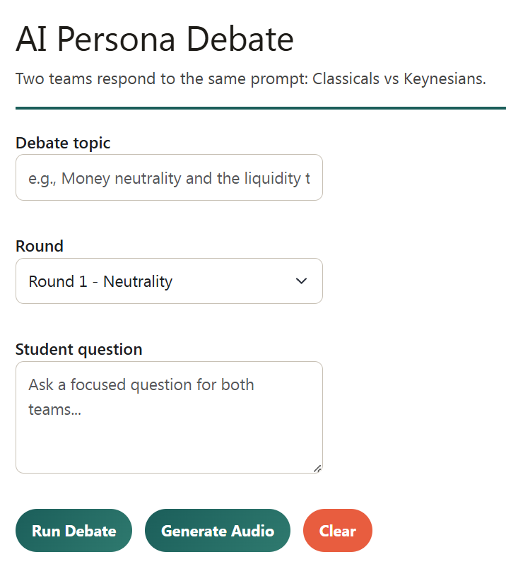

Technical Implementation
The application is built with Gradio and hosted on Hugging Face Spaces at a stable URL, then embedded via iframe in the course's Quarto website. Gradio is lightweight, free to host at single-module class size, requires no server administration from the instructor, and renders cleanly inside an iframe without framework conflicts.
The persona architecture uses a small set of system prompts — one per persona — each fixing the economist's theoretical commitments in language they would plausibly have used, the concepts they are expected to deploy, and explicit constraints against breaking character or endorsing anachronistic positions. A round-specific scaffold then narrows each persona's focus to the selected topic. This two-layer structure (persona prompt × round prompt) keeps responses on-topic without collapsing the within-school distinctions that are central to the activity's design.
Two implementation details are worth noting for colleagues wishing to replicate the activity. First, Hugging Face Spaces iframes can carry conversational state across page loads; without intervention, a student loading the page can inherit the previous student's debate. The course site therefore deploys a small JavaScript block that clears the relevant keys and forces an iframe cache-buster on each load. Second, terse persona prompts consistently outperform verbose ones: shorter, more pointed prompts yield more idiosyncratic — and therefore more pedagogically useful — disagreement between the personas. Long persona prompts tend to collapse into generic responses that lose the within-school distinctions. At single-module class size, the activity has operated within the Hugging Face Spaces free tier.

Student Response
Formal evaluation is in progress; what follows should be read as observed patterns in early deployment rather than as claims supported by a completed study.
Three patterns are visible. Students spend more time on the liquidity-preference round than on either of the other two, which may reflect its greater conceptual difficulty or the more visible disagreement the personas produce on this topic — distinguishing these will require a think-aloud protocol or post-activity survey. Question quality improves within a single session: early questions tend to seek conclusions ("Does QE work?"), while later questions seek mechanisms ("Through which channel does QE operate if the liquidity trap binds, and how does your answer differ from Keynes's?"). Real scenario questions increased with the development of the course in fields such as crypto, stocks, and Fed abd BoE monetary economic decisions. This progression from conclusion-seeking to mechanism-seeking is the transferable skill the activity is designed to cultivate.
Students who struggle tend to do so at the question-generation step rather than at the comprehension step — a pedagogically useful signal suggesting that the bottleneck is framing a productive challenge, not reading the personas' answers. In response, the reflection prompt now includes a scaffolded question-ladder exercise to be completed before engaging the personas.
Formal outcome measurement is planned for the next cohort. Intended indicators include pre/post conceptual items on money neutrality and the liquidity trap, an assessed short essay in which students reconstruct one within-school disagreement (for example, Keynes versus Hicks on the interpretation of the General Theory), and an end-of-module survey on the activity's perceived usefulness.

Critical Reflection
Four risks deserve explicit acknowledgement.
Hallucination and misattribution. The personas are LLMs prompted to approximate their historical counterparts, not faithful reconstructions. On well-documented positions the approximation is reasonable; on fine-grained questions they can produce confident statements that no careful historian of thought would endorse. Students are warned of this in the activity preamble. A follow-up task in the workbook asks them to verify one claim per persona against a primary source from the reading list, turning the hallucination risk into a source-evaluation exercise.
Assessment integrity. The activity is currently formative. Any move to summative assessment must address the fact that students can use identical tooling to generate the essays the module would ask them to write. The appropriate response is to assess the question-generation step and the reflection, not the transcript — but this requires redesign of the marking rubric.
Inequality of prior preparation. Students who have completed the reading extract considerably more from the personas because they can recognise when a persona is paraphrasing a canonical argument versus when it is drifting. Active-learning formats amplify this gap; the question-ladder scaffold is one mitigation, but the issue is not fully resolved.
Simulated consensus. LLMs trained to be agreeable can converge two opposed personas on an anodyne middle position that represents neither Classical nor Keynesian thought. Round-specific prompts partially mitigate this, but it remains the most fragile element of the design and the one most dependent on the quality of the student's challenge question.

Conclusion
The contribution of this activity is modest and specific. It does not claim that AI personas replace lectures, seminars, or primary reading. It claims only that, at low marginal cost, they provide a rehearsal space in which students can test their own challenge questions against the two most important schools of thought in monetary economics — and that the act of generating those questions is itself where the learning lives. As AI-pedagogy entries accumulate in the Economics Network Ideas Bank, the relevant question is no longer whether to use these tools but which parts of economics education they serve well. History of economic thought, with its premium on mechanism-level disagreement, is one such part.

References
Freeman, S., Eddy, S. L., McDonough, M., Smith, M. K., Okoroafor, N., Jordt, H., & Wenderoth, M. P. (2014). Active learning increases student performance in science, engineering, and mathematics. Proceedings of the National Academy of Sciences, 111(23), 8410–8415. https://doi.org/10.1073/pnas.1319030111
Hicks, J. R. (1937). Mr. Keynes and the "Classics": A suggested interpretation. Econometrica, 5(2), 147–159. https://doi.org/10.2307/1907242
Kasneci, E., Sessler, K., Küchemann, S., Bannert, M., Dementieva, D., Fischer, F., … Kasneci, G. (2023). ChatGPT for good? On opportunities and challenges of large language models for education. Learning and Individual Differences, 103, 102274. https://doi.org/10.1016/j.lindif.2023.102274
Keynes, J. M. (1936). The General Theory of Employment, Interest, and Money. Macmillan.
Patinkin, D. (1956). Money, Interest, and Prices. Harper & Row.
Pigou, A. C. (1943). The classical stationary state. Economic Journal, 53(212), 343–351. https://doi.org/10.2307/2226394
Strobel, F. (2026, March). Building classroom economics games with AI-assisted coding. Economics Network Ideas Bank, University of Birmingham. [Verify URL before submission]
Walras, L. (1874). Éléments d'économie politique pure. Corbaz.

*Please add ORCID if available · Suggested categories: Technology-enhanced learning; History of economic thought

